The Influence of a Central
Vacuum System on Quality of Life
in Patients with House DustAssociated Allergic Rhinitis
Stanley M. Naguwa and M. Eric Gershwin
Division of Rheumatology, Allergy and Clinicallmmunology,
University of California at Davis School of Medicine, Davis, CA, USA
Summary.
Indoor pollution is one of the most common problems addressed by allergists and troublesome for their patients. Although a large variety of products are available for removing such pollutants, including house dust, there is a relative paucity of data on the effectiveness of such devices. In many cases, central vacuum systems are recommended, particularly in new homes. To specifically Rhinoconjunctivitis Quality of Life Questionaire, we selected 25 individuals with a history of documented type I hypersensitivity to months. At the end of this period, the individual switched over to the opposite limb of the study for 3 additional months. Interestingly, in all seven domains of the evaluation, including activity, sleep, nonnasal syptoms, practiacal problems, nasal symptoms, eye symptoms and emotions, use of the central vacuum proved to be superior. Keywords: house dust, rhinitis, Juniper Quality of Life scores, vacuums.
Introduction
Allergies are among the most common and troublesome ailments. House dust allergy is especially common, and many products are recommended to reduce the level of dust and improve symptoms. A sizeable industry now exists to supply and service air cleaners, vacuum cleaners, dust-removal kits and bedding fabric covers. An unanswered question is whether a central (built-in) vacuum system is more effective in reducing rhinitis symptoms than conventional (upright and canister) vacuum cleaners. To address this issue, a sample of 25 participants with a history of documented type I hypersensitivity to house dust and rhinitis symptoms were selected for study. In each home the only variable altered for the study was installation of a Beam central vacuum system. Participants used either a conventional or central vacuum system for 3 months, then crossed over. Subjects then completed the Juniper Rhinoconjunctivitis Quality of Life questionnaire (RQLQ) serially for 6 months. We report herein that use of a central vacuum cleaner was superior to a conventional vacuum in all seven domains of the RQLQ.
Materials and Methods
In this study, a total of 25 individuals were selected based upon a history of documented type I hypersensitivity to house dust as well as symptomatic rhinitis exacerbated by dust exposure. All subjects lived in a one story home with an average square footage of2136 or 235 square meters. The average age of the home was 13.5 years and 60% of the homes were covered with carpet. Participation in this study was approved by the University of California's Institutional Review Board. All subjects were adults. There were 18 female participants and 7 males, ranging in age from 32 to 64. In each case, a central vacuum system (Beam lndustries) model #2100 was installed in their home. Subjects were asked to complete the Juniper Quality of Life Questionnaire on a serial basis for a total of 6
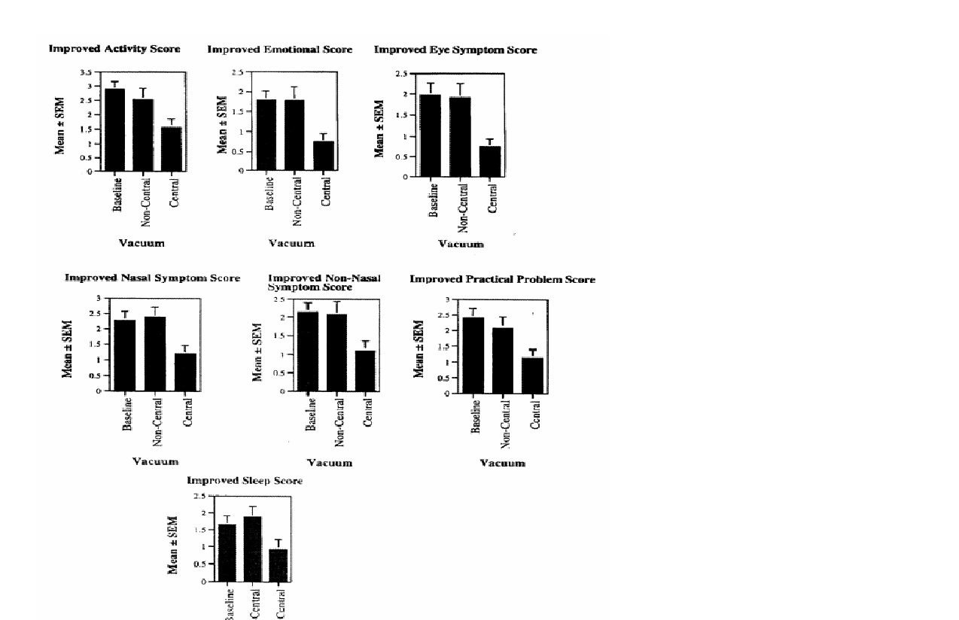

Figure 1. Juniper Rhinoconjunctivitis Quality of Life Scores for seven domains. Note that the central vacuum is significantly different from the original, or noncentral vacuum (p < 0.05). The data is also significatly better than baseline months. Half of the individuals used either a central vacuum system or their own vacuum for three months, followed by a cross over. The questionnaires were not evaluated until the end of the study. The Quality of Life Questionnaire evaluated the quality of rhinoconjunctivitis symptoms using standardized activities, including nose or eye symptoms at work, during activities with family and friends, or outdoors; sleep, including difficulty getting to sleep, waking up at night, or lack of a good night's sleep; non-nose/eye symptoms, including fatigue, thirst, reduced productivity, tiredness, poor concentration, headache, feelings of being worn out; practical problems including inconvenience of having to carry a handkerchief, the rubbing of nose or eyes, having to blow your nose; nasal symptoms, including stuffy/blocked nose, runny nose, sneezing and postnasal drip; eye symptoms, including itchy eyes, watery eyes, sore eyes and swollen eyes; and emotional symptoms, including feelings of frustration, restlessness, irritability or being embarrassed by symptoms. Details of the questionnaire and the scoring, using a rating from 0-6, can be found at http://www.fhs.mcmaster.ca/hrqoVqolintro.htm. Permission to use the Rhinoconjunctivitis Quality of Life Questionnaire was kindly provided by Dr. Elizabeth Juniper of McMaster University.
Statistical Analysis
For statistical analysis, the baseline value and week 0 are the same observation. Tukey's test was used to determine whether the vacuum types differed amongst each other. The data at baseline, week 12 and week 24 were compared. The Tukey's studentized range (HSO) was used to control for the type I experiment-wise error rate.
Results
The results of the self-administered RQLQ demonstrate: an improvement of the RQLQ scores with use of the central vacuum system in all seven domains-activity, sleep, nonnasal symptoms, practical problems, nasal symptoms, eye symptoms and emotions (Figure 1). A change of 0.5 in the score is considered significant [1]. As noted in Figure 1, the change in the activity domain score after 12 weeks of central vacuum use, as compared to baseline, was -1.32, the sleep domain -0.72, nonnasal sleep domain -1.03, practical problem domain -1.25, nasal symptom domain -1.06, eye symptom domain -1.21 and emotions domain -1.04. The score change is expressed in negative values as the closer to zero one approaches, the more asymptomatic the state. The comparison of RQLQ scores are tabulated in Figure 1 along with the statistical differences between baseline, after 12 weeks of original (noncentral) vacuum use and after 12 weeks of a central vacuum use. The differences in the scores between the use of the central vacuum system versus baseline and original vacuum use was significant at p < 0.05. There was no statistical difference between the original vacuum use and baseline as would be expected.
Discussion
House dust mite (HDM) sensitivity bas been noted in a significant portion of patients suffering from allergic rhinitis [2]. Because of HDM omnipresence, except in arid climate [3], and perennial presence, measures to avoid or control exposure in the home are important in the management of the disease. Avoidance/control measures strive to control HDM replication and HOM allergen exposure. While there are studies evaluating the efficacy of these measures in the management of asthma [4-6], there are few in allergic rhinitis management [7]. The house dust mites (D. farinae pteronysinus, B. tropicalis) have strictly defined temperature and relative humidity requirements to survive and replicate. However, even with air conditioning systems, creating an environment adverse to mite survival may be difficult or expensive [8, 9]. Air conditioners/central hearing units may be outfitted with filters to remove HOM allergens with each method having its advantages and disadvantages. HEPA "filters are replaceable, may not require a retrofit but in- crease air flow resistance as the filter becomes "loaded." Electrostatic filters are helpful in removing allergens but are expensive and generate ozone, a concern recently studied [10]. Given that the human body can provide warmth, humidity (via insensible water loss), and food for the HDM, the bedding in which we may spend 1/3 to 1/4 of our lives provides an ideal domicile. Allergen control can be achieved by washing bedding in hot (> 130°FI55°C) water, and enclosing pillows, comforters and mattresses in "mite proof' coverings [11]. The least expensive but most uncomfortable coverings are of plastic; the newer vapor permeable coverings are comfortable but expensive. Mites may also be killed with extremes of temperature [4]. Vacuums, the focus of this study, are the prime mode of HOM allergen removal from carpets and furniture. :'Vacuum systems should have sufficient suction to remove the HOM allergen and confine it to the collection unit [11]. It would seem that a central vacuuming system would best provide such capabilities as it would be in- stalled outside of the living area of the dwelling and/or vented outdoors. There, motor noise would not be a factor in providing suction power and the vacuumed allergens would be transported out of the living area dispensing with the concerns of allergen leakage from the vacuuming unit or allergen spread trough the vacuum cleaner exhaust [12]. Our study utilised such a central vacuuming system and assessed its impact on the patient's qualify of life (QOL) utilizing a validated instrument of study [1]. The data demonstrated a significant impact on all domains of "the QOL With the use of a central vacuuming unit versus; the patient's previous noncentral (conventional) vacuum use. Caution should be exercised when interpreting the data because of the lack of a "control" in which the central vacuum unit would be vented into the living area. There was no practical way of blinding, e. g., connecting the central vacuum unit to the central heating ducts, without concerns of violating the rights of human subjects. Where the symptom-causing substances are not consciously brought into the house, barriers should be erected to keep the offending substance out of the house. This tactic is appropriate for plant pollens, outdoor dust, atmospheric pollutants (industrial or automotive). None of these allergens is particularly easy to manage. The standard response to these invaders is to install or upgrade the central heating/air conditioning. The problems are that, first, pollen or pollutant-laden air can find ways around a central heating/air-conditioning system, especially in older, more loosely-constructed dwellings. Second, the central heating/air conditioners themselves may not be able to remove all of the offending matter. Third, bringing in new or modifying existing systems can be expensive, especially if the objective is to improve air quality. Indeed, sometimes, as in the case of rented quarters, such an approach may be out of the question. Where central heating/air-conditioning units are in place or installable, they can be made to work more effectively by using specially made filters, These come in a number of different forms. First there are extremely fine HEPA (High Efficiency Particulate Arresting) filters made of glass fibers formed into a paper-like accordion-pleated sheet. The air driven by the fan is forced through this fine screen and it traps most of the airborne particulate material. The best of these filters will remove 99% or more of particles that are > 0.3 microns in diameter (pollen spores measure between 8 and 100 microns in diameter; industrial dust particles run 100 or more microns in diameter. Much of automotive and industrial particulate material is smaller than the 0.3 micron standard and will pass through the HEPA harrier as will symptom-producing gases like ozone and nitrous oxide. And to meet the 99% criterion the filter must be installed so as to make a tight seal with no blow-by. Forced air, like water, follows the path of least resistance. As a practical matter, in the many instances where central air conditioning is either not in place or not feasible for the home, a window-mounted air conditioning unit may represent an alternative. Roomsized units can be fitted with any of the types of filters described above and if the device is installed snugly and the room itself is kept closed off from the rest of the dwelling, it can offer the sufferer considerable local relief from airborne particulate matter, especially if installed in the bedroom. Indeed. Beface the advent of home air conditioning it was common practice for hay fever victims to attend an air-conditioned movie when the pollen got bad; nowadays it's off to the mall. Room air cleaners or air purifiers (not air conditioners) are useful in controlling airborne particulate matter-pollens, animal dander, molds, dust, smoke and other pollutants (including those produced by cooking or heating), and some gaseous material in a confined spare if no temperature regulation is desired. These devices take a number of forms but, in general, they act by recirculating the air in the room through a collector-HEPA. Electret, electrostatic filters, or ionizers. Mites (Dermatophagoides farinae) and other foreign proteins such as insect parts or leavings are a major cause of respiratory disease and represent the triggering agent in what is commonly referred to as house dust allergy. Mites are minute, free-living organisms, arthropods, members of the spider family, that subsist on human skin scales. Their inhaled leavings are a primary cause of asthma and chronic hay fever. They avoid light and require a warm, humid environment. They are persistent, prolific, and resist eradication; most insecticides that will control them are dangerous to humans. Conventional cleaning methods rail to eliminate them, either because they are found in places not efficiently reached by ordinary procedures, or the procedures themselves (noncentral vacuuming system, for example) actually disperse the organisms throughout the environment. Air cleaners or purifiers (despite claims to the contrary) are not especially effective as a means of control of these pests because, for the most part, they are not airborne; they are best managed by careful cleaning, complemented by environmental control measures and the use of hypoallergenic decor. Bedrooms should feature clear, smooth nonporous surf aces to the fullest possible extent. These surfaces should be mopped every two to three days with a clean damp cloth. If the person who does the cleaning is also the one who reacts to dust, he or she should wear a mask capable of filtering out particles out micron in diameter. Ordinary paper masks of the kind worn by construction workers will not meet this standard; newer, effective, tighter fitting masks are now available at a reasonable cost. In addition to regular, thorough, attentive dust-mop- ping of all surfaces, dust-attracting devices should receive special attention. Electronic gear-radios, TVs, audio systems, speakers, VCRs, computers, etc.-should be kept as free as possible of dust, stored in an enclosed space, and covered when not in use. House plants also catch dust (as well as generate mold, mildew, and plant spores or pollen) and should be relegated to the guest room. Venetian or similar slatted blinds should be gone over carefully on each cleaning occasion. Special cleaning or polishing agents are not necessary and, in fact, some of them are known to trigger reactions in some persons. Several firms manufacture special vacuum cleaners that feature either water traps, HEPA filters, or high suction. These devices have been studied to establish their efficacy [11]. The caveat is that model changes occur frequently. They may be an alternative for those patients who move frequently.
References:

1. Juniper,E.F., Thompson, A.K., Ferrie, P.J., Robel1s,J.N. Validation of the standardized version of the Rhinoconjunctivitis Quality of Life Questionnaire. J Allergy Clin Immunol 1999,104(2, Pt. 1), 364-369.
2. Galant, S., Berger, W., Gillman, S., Goldsobel, A., lncaudo, G., Kanter, L., Machtinger, S., McLean, A., Prenner, B., Sokol, W., Spector, S., Welch, M., Ziering, W. PrevaJence of sensitization to aeroallergens in California patients with respiratory allergy. Allergy Skin Test Project Team. Ann Allergy Asthma immunol 1998, 81(3), 203-210.
3. Huss, K., Adkinson, N.F., Eggleston, P.A., Dawson, C., Van Natta, M.L., Haffillton, R.G. House dust mite and cockroach exposure are strong risk factors for positive allergy skin test responses in the Childhood Asthma Management Program. J Allergy Clin Immunol 2001, 107(1),48-54.
4. Htut, T., Higenbottam, T.W., Gill, G. W., Darwin, S.R., Anderson, P.B., Syed, N. Eradication of house dust mite from homes of atopic asthmatic subjects: a double-blind trial. J: AllergyClinJmmuno/2001, 107(1), 55-60.
5. Nelson, H.S. The impol1ance of allergens In the development of asthma and tbe persistence of symptoms. J Allergy Clin : Immunol 2000, 105(6, Pt. 2), S628-S632.
6. Sporik, R., Hill, D.J., Thompson, P.J., Stewart, O.A., Carlin, J.B., Nolan, T.M., Kemp, A.S., Hosking, C.S. The Melbourne House Dust Mite Study: long-term efficacy of house dust mite reduction strategies. J Allergy Cim Immunol 1998, 101 (4, Pt. 1), 451-456.
7. Corren, J. Allergic rhinitis: treating tbe adult J Allergy Clin ImmunoI2000, 105 (6, Pt. 2), S610-S615.
8. Niven, R., Fletcher, A.M., Pickering, A.C., Custovic, A., Sivour, J.B., Preece, A.R., Oldham, L.A., Francis, H.C. Attempting to control mite allergens with mechanical ventilation and dehumidification in British houses. J Allergy Clin Immunol 1999, 103(5, Pt. 1),756-762.
9. Warner, J.A., Frederick, J.M., Bryant, T.N., Weich, C., Raw, G.J., Hunter, C., Stephen, F.R., McIntyre, D.A., Warner, J.O. Mechanical ventilation and high-efficiency vacuum cleaning: A combined strategy of mite and mite allergen reduction in the control of mite- sensitive asthma. J Allergy Clin Immunol 2000, 105(1, Pt. 1),75-82.
10. Walby, W.F. Effect of house dust mite allergen and orone, alone or in combination in infant rhesus monkeys. J Allergy Clin ImmunoI2000, 105, A274. 11. Platts-Mills, T.A., Vaughan, J. W., Carter, M.C., Woodfolk, J.A. The role of intervention in established allergy: Avoidance of indoor allergens in the treatment of chronic allergic disease. J Allergy Clin Immunol 2000, 106 (5, Pt. I), 787-804
12. HUD. HUD guidelines for the evaluation and control of lead based paint hazards in housing. HUD, Chapter 14, pp. 22- 23.

